36.58: a) 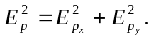So, from the diagram at right,
we have:
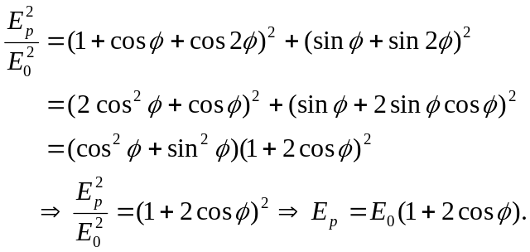
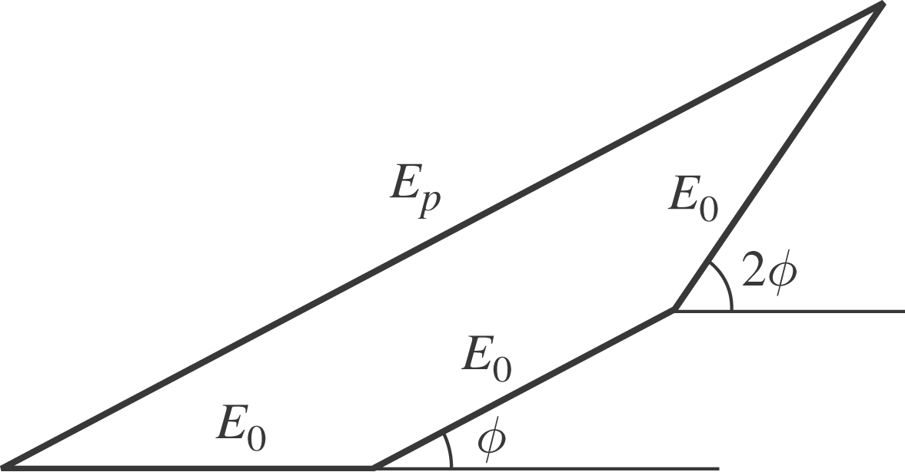

b) 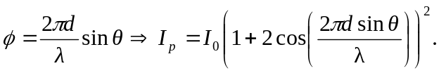 This is graphed below:
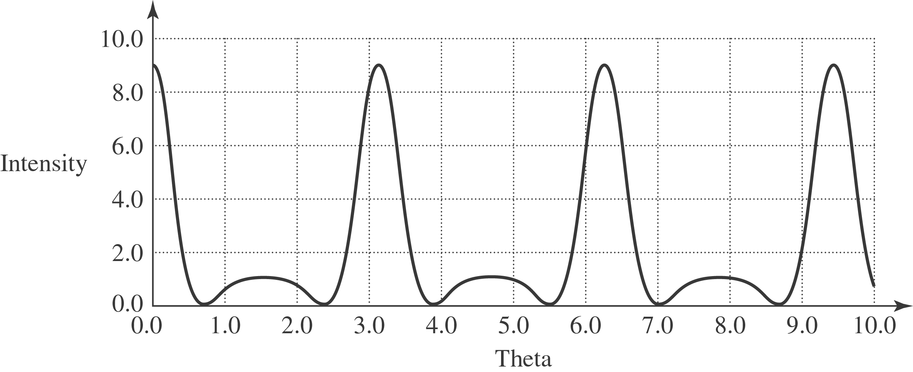

c) (i) At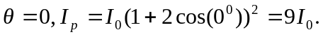
(ii) The principal maximum is when 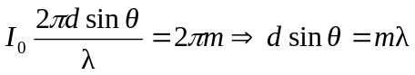
(iii) & (iv) The minima occur at 2 cos 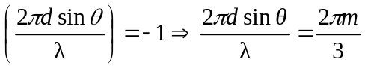
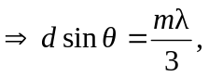with m not divisible by 3. Thus there are two minima between every principal maximum.

(v) The secondary maxima occur when cos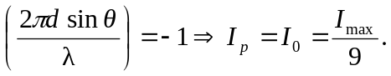
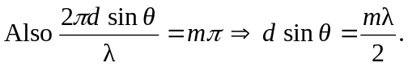
All of these findings agree with the statements in Section 35.5.
d) Below are phasor diagrams for specific phase shifts.

